Aggregation in SQL

Use World Database to solve the following questions
(Hint : World Database is inbuilt in SQL Workbench so use code “use world;” to make use of the database)

Question 1 : Count how many cities are there in each country?
Solution :-
SELECT c.Name AS CountryName, COUNT(ci.ID) AS TotalCities FROM country c JOIN city ci ON c.Code = ci.CountryCode GROUP BY c.Name
ORDER BY TotalCities DESC;
Few results are below :
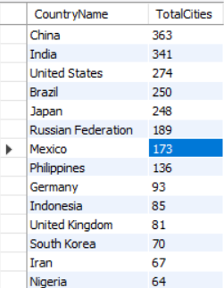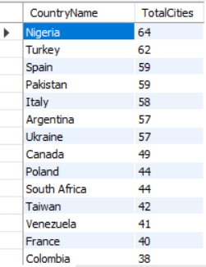
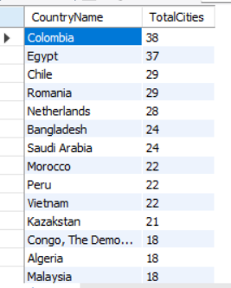
Question 2 : Display all continents having more than 30 countries.
Solution :-
SELECT Continent, COUNT(*) AS TotalCountries FROM country GROUP BY Continent HAVING COUNT(*) > 30;
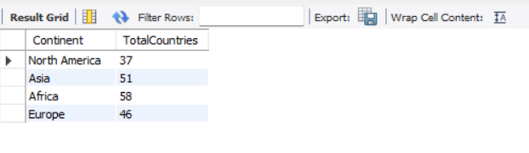

Question 3 : List regions whose total population exceeds 200 million.
Solution :-
SELECT Region, SUM(Population) AS TotalPopulation FROM country GROUP BY Region HAVING SUM(Population) > 200000000;
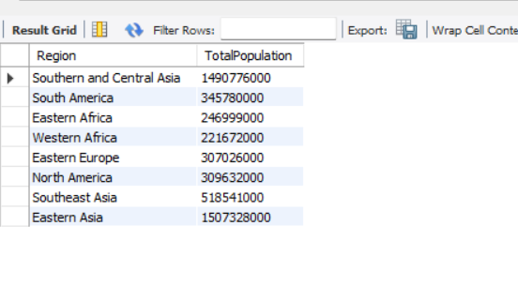

Question 4 : Find the top 5 continents by average GNP per country.
Solution :-
SELECT Continent, AVG(GNP) AS AvgGNP FROM country GROUP BY Continent ORDER BY AvgGNP DESC LIMIT 5;
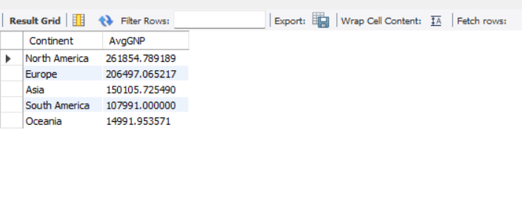

Question 5 : Find the total number of official languages spoken in each continent.
Solution :-
SELECT c.Continent, COUNT(DISTINCT cl.Language) AS TotalOfficialLanguages FROM country c JOIN countrylanguage cl
ON c.Code = cl.CountryCode WHERE cl.IsOfficial = 'T' GROUP BY c.Continent;

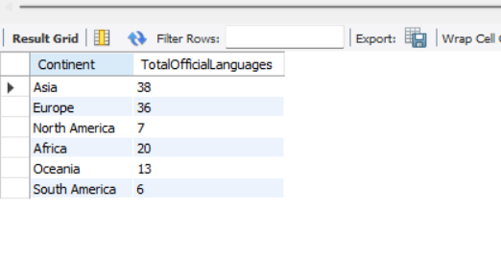

Question 6 : Find the maximum and minimum GNP for each continent.
Solution :-
SELECT Continent, MAX(GNP) AS MaxGNP, MIN(GNP) AS MinGNP FROM country GROUP BY Continent;
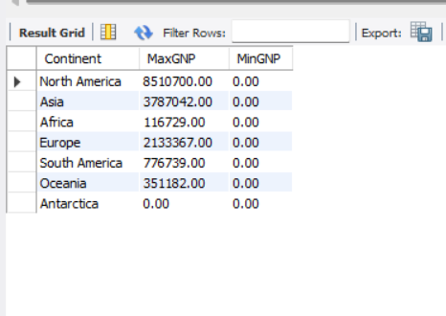

Question 7 : Find the country with the highest average city population.
Solution :-
SELECT c.Name AS CountryName, AVG(ci.Population) AS AvgCityPopulation FROM country c JOIN city ci
ON c.Code = ci.CountryCode GROUP BY c.Name ORDER BY AvgCityPopulation DESC LIMIT 1;


Question 8 : List continents where the average city population is greater than 200,000.
Solution :-
SELECT c.Continent, AVG(ci.Population) AS AvgCityPopulation FROM country c JOIN city ci
ON c.Code = ci.CountryCode GROUP BY c.Continent HAVING AVG(ci.Population) > 200000;
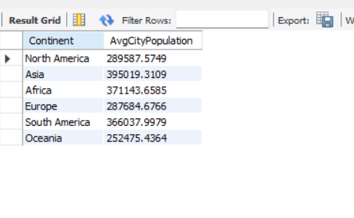

Question 9 : Find the total population and average life expectancy for each continent, ordered by average life expectancy descending.
Solution :-
SELECT Continent, SUM(Population) AS TotalPopulation, AVG(LifeExpectancy) AS AvgLifeExpectancy FROM country GROUP BY Continent
ORDER BY AvgLifeExpectancy DESC;
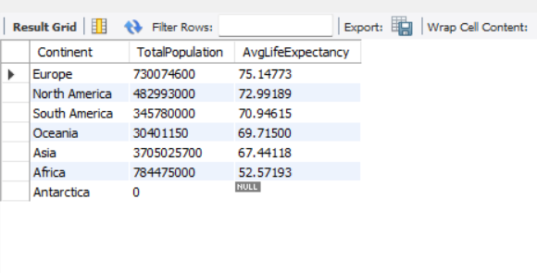

Question 10 : Find the top 3 continents with the highest average life expectancy, but only include those where the total population is over 200 million.
Solution :-
SELECT Continent, AVG(LifeExpectancy) AS AvgLifeExpectancy, SUM(Population) AS TotalPopulation FROM country GROUP BY Continent
HAVING SUM(Population) > 200000000 ORDER BY AvgLifeExpectancy DESC LIMIT 3;
